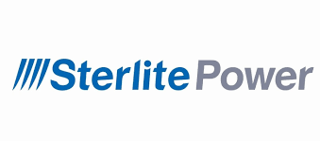

**Overview**

Sterlite Power is a leading private sector power transmission infrastructure developer

and solutions provider. Core purpose of Sterlite Power is ‘empowering humanity by addressing the toughest challenges of clean energy delivery’. Company have completed 33 projects and others are under construction covering approximately 16,529 circuit kms of transmission lines across India and Brazil. Sterlite Power has established itself as a prominent player in the power transmission sector through its innovative practices and strategic collaborations.

**FINANCIAL HIGHLIGHTS**

|  |  |  |  |  |
| --- | --- | --- | --- | --- |
| Particulars | 2021 | 2022 | 2023 | 2024 |
| Revenue (Crs) | 2092 | 5197 | 3279 | 4918 |
| PAT (Crs) | 869.7 | 440.1 | 183.4 | 230.1 |
| EPS (Rs) | 59.32 | 35.97 | -2.67 | -17.7 |

**UPDATES**

* Infravision partnerships with Sterlite power in November 2024 to revolutionize India’s transmission infrastructure by using advanced and technology enabled construction methods.
* In the beginning of the FY25, the company order book stands at INR 6,560 crores.
* In Q1FY25, It has won orders worth of INR 1500 crores.
* Sterlite Power won orders worth of INR 1200 crores in Q2FY25.

**SHAREHOLDING PATTERN**

( +91 7827759286|sales@bharatinvest.com|www.bharatinvest.com )

|  |  |
| --- | --- |
| Shareholder | Holding(%) |
| Twin Star Overseas Limited, Mauritius | 71.34% |
| Others | 28.62% |